AN1299 Demonstration ReadMe for the  
dsPICDEM™ MCLV-2 Development Board with the dsPIC33CK256MP508 Internal Op-Amp Motor Control PIM (MPLAB® X IDE)

1. Introduction

This document describes the setup requirements for running the Single-Shunt Reconstruction Algorithm, which is referenced in AN1299 “Single-Shunt Three-Phase Current Reconstruction Algorithm for Sensorless FOC of a PMSM”.

The demonstration is configured to run on the dsPICDEM™ MCLV-2 Development Board in Internal Op-Amp configuration with the dsPIC33CK256MP508 Internal Op-Amp Motor Control Plug-In Module (PIM).

1. Suggested Demonstration Requirements
   1. Motor Control Application Firmware Required for the Demonstration

* AN1299_dsPIC33CK256MP508_EXT_INT_OPAMP_MCLV2_MCHV2_MCHV3.zip

**Note:**

In this document, hereinafter this firmware package is referred as firmware**.**

* 1. Software Tools Used for Testing the firmware
* MPLAB® X IDE v5.10
* MPLAB® XC16 Compiler v1.36b
* MPLAB® X IDE Plugin: Data Monitor and Control Interface (DMCI) v2.71
* MPLAB® X IDE Plugin: Latest version of X2CScope Plug-in

**Note:**

The software used for testing the firmware prior to release is listed above. It is recommended to use the version listed above or later versions for building the firmware.

* 1. Hardware Tools Required for the Demonstration
* dsPICDEM™ MCLV-2 Development Board (DM330021-2)
* 24V Power Supply (AC002013)
* 24V 3-Phase Brushless DC Motor(AC300020)
* dsPIC33CK256MP508 Internal Op-Amp Motor Control Plug-in module (MA330041-2)
* Microchip Programmer tools like MPLAB® REAL ICE™ In-Circuit Emulator (DV244005) or MPLAB® ICD 3 (DV164035) etc.

**Note:**

All items listed under the section 2.3. Hardware Tools Required for the Demonstration are available at [microchip DIRECT](http://www.microchipdirect.com/).

1. Hardware Setup

This section describes hardware setup required for the demonstration. Motor phase current feedbacks needed by the firmware are amplified by the operational amplifiers that are internal to the dsPIC33CK256MP508. This is referred as ‘*Internal amplifier configuration*’.

1. By default, internal op-amp which is used for Bus current measurement is not configured. Refer [**dsPIC33CK256MP508 Motor Control PIM for Internal Op Amp Configuration**](http://ww1.microchip.com/downloads/en/DeviceDoc/dsPIC33CK256MP508-Motor-Control-PIM-for-Internal-Op-Amp-Configuration-DS50002756A.pdf)**.pdf** for more information. Please do as per below note to configure OP-AMP1.

* As shown in the diagram remove R23, R24, R25, R26 to enable IBUS current to configure Op-AMP1 for amplifying Bus Current.

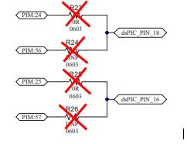

* Also populate the input and gain resistors of Op-Amp 1

R22 = R19 = 4.99KΩ

R20 = 0Ω

R15 = R17 = 300Ω

R16 = R18 = 33 Ω

C15 = 1000pF

C14, C16, R21 = DNP (Do not populate)

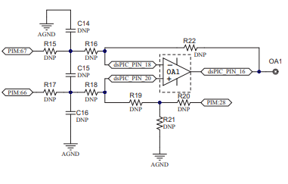

1. Disconnect power to the dsPICDEM™ MCLV-2 Development Board and set up the following jumpers:

|  |  |  |
| --- | --- | --- |
| Jumper | Pins to Short | Board Reference |
| JP1 | 1-2(**Curr**-Current) | C:\Users\I14883\Desktop\Current Jumpers.png |
| JP2 | 1-2(**Curr**-Current) |
| JP3 | 1-2(**Curr**-Current) |
| JP4 | USB position |
| JP5 | USB position |
| J5 | Don’t care |
| JP11 | Don’t care |

1. Connect the three phase wires from the motor to M1, M2, and M3 terminals of connector J7(there is no specific order), provided on the dsPICDEM™ MCLV-2 Development Board.

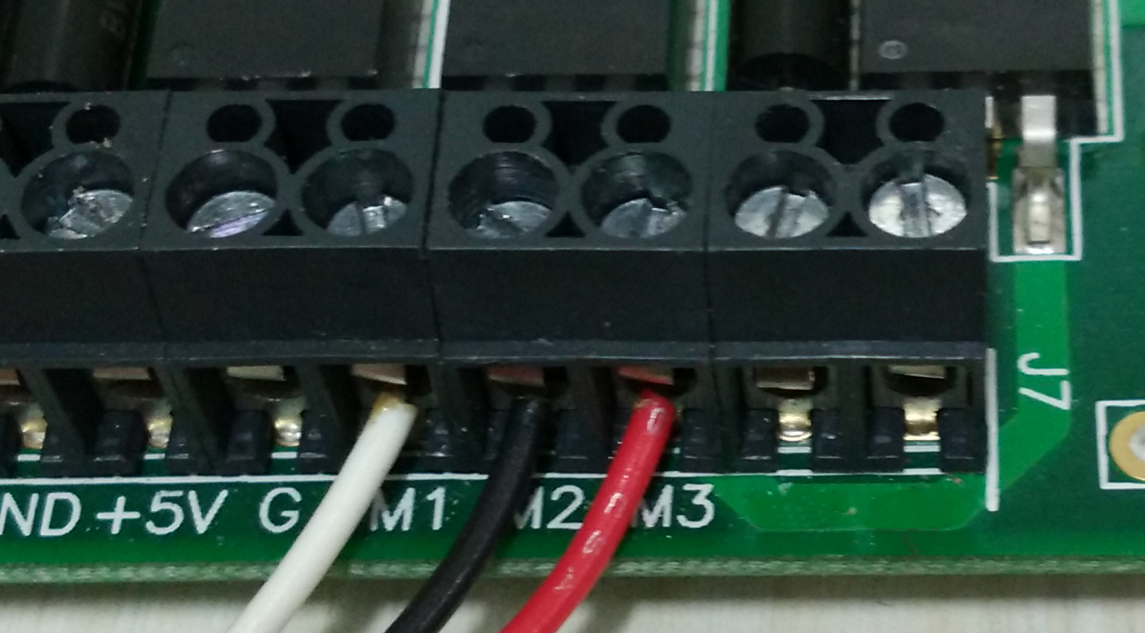

1. Insert the ‘Internal Op-Amp Configuration Matrix board’ into matrix board header J14. Ensure the matrix board is correctly oriented before proceeding.

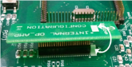

1. Insert the dsPIC33CK256MP508 Internal Op-Amp Motor Control PIM into the PIM Socket U9 provided on the dsPICDEM™ MCLV-2 Development Board. Make sure the PIM is correctly placed and oriented before proceeding.
2. Plug in the 24V power supply to connector J2 provided on the dsPICDEM™ MCLV-2 Development Board.



1. Connect the Microchip programmer/debugger tools like MPLAB REAL ICE™ or MPLAB ICD-3™ to the Connector J11 of the dsPICDEM™ MCLV-2 Development Board and to the Host PC used for programming the device.
2. Software Setup and Run
   1. Setup: MPLAB X IDE and MPLAB XC16 Compiler

Install MPLAB X IDE and MPLAB XC16 Compiler versions that support the device dsPIC33CK256MP508 assembled on the Plug-in Module (PIM). The version of the MPLAB X IDE, MPLAB XC16 Compiler and DMCI plug-in used for testing the firmware are mentioned in the section Motor Control Application Firmware Required for the Demonstration. To get help on

* MPLAB X IDE installation, refer [link](http://microchipdeveloper.com/mplabx:installation)
* MPLAB XC16 Compiler installation steps, refer [link](http://microchipdeveloper.com/xc16:installation)

If MPLAB IDE v8 or earlier is already installed on your computer, then run the MPLAB driver switcher (It is installed when MPLAB®X IDE is installed) to switch from MPLAB IDE v8 drivers to MPLAB X IDE drivers. If you have Windows 7 or 8, you must run MPLAB driver switcher in ‘Administrator Mode’. To run the Device Driver Switcher GUI application as administrator, right click on the executable (or desktop icon) and select ‘Run as Administrator’. For additional details refer MPLAB X IDE help topic *“Before You Begin: Install the USB Device Drivers (For Hardware Tools): USB Driver Installation for Windows Operating Systems”.*

* 1. Setup: Data Monitor and Control Interface (DMCI)

The Data Monitor and Control Interface (DMCI) is a MPLAB X IDE plugin that allows a developer to interact with an application while the application program is running. DMCI provides a graphical user interface which operates within the IDE enabling the developer to examine or modify the contents of application variables without having to halt the application during a debug session. For additional information on DMCI follow the [link](http://microchipdeveloper.com/mplabx:dmci). To use DMCI, the plugin must be installed:

* In MPLAB X IDE, select Tools>Plugins and click on the **Available Plugins** tab.
* Select DMCI plug-in by checking its check box, and then click **Install**.
* Look for your tool DMCI under Tools>Embedded. If you do not see it, you may need to

close and re-open MPLABX IDE.

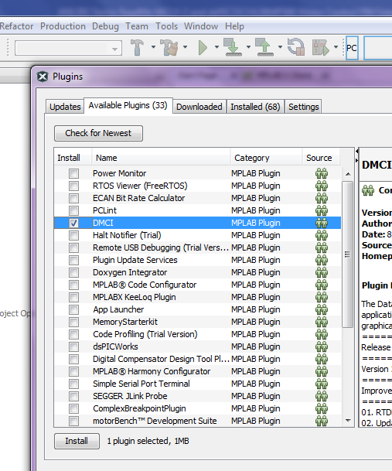

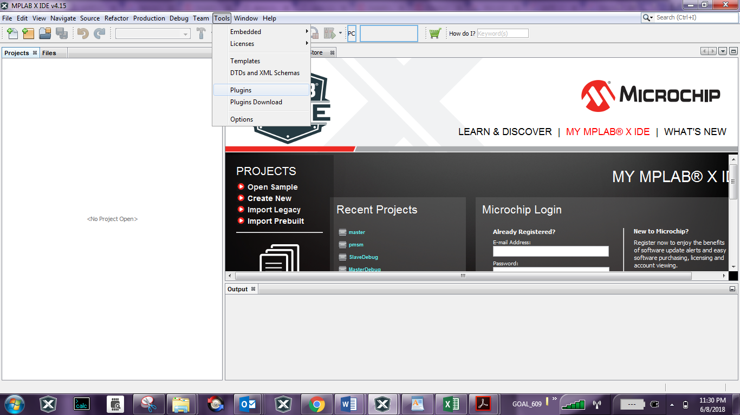

* 1. Setup: X2C - SCOPE

X2C - SCOPE is a MPLAB X IDE plugin that allows a developer to interact with an application while the application program is running. X2C-Scope enables you to read, write, and plot global variables (for motor control) in real time. It communicates with the target using the UART. To use X2C, the plugin must be installed:

* In MPLAB X IDE, select Tools>Plugins and click on the **Available Plugins** tab.
* Select X2C - SCOPE plug-in by checking its check box, and then click **Install**.
* Look for your X2C - SCOPE under Tools>Embedded.

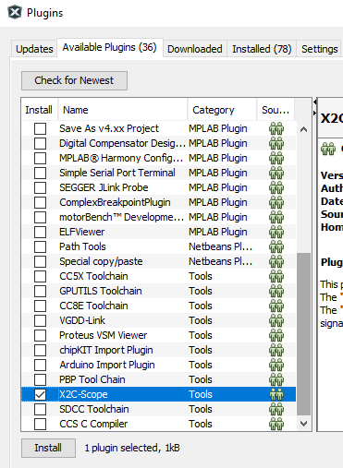



1. Basic Demonstration
   1. Firmware Description

The firmware version required for the demonstration is mentioned under the section Motor Control Application Firmware Required for the Demonstration.

This firmware is implemented to work on Microchip’s 16-bit Digital signal controller (dsPIC® DSC) dsPIC33CK256MP508**.** For more information, see the *dsPIC33CK256MP508 Family datasheet(DS70005349)*.

The Motor Control Demo application uses push button to start or stop the motor and potentiometer to vary speed of the motor.

This Motor Control Demo Application configures and uses peripherals like PWM, ADC, Op-Amp, UART etc. required for implementing Sensor-less Field Oriented Control (FOC) of Permanent Magnet Synchronous Motor (PMSM) based on the motor control application AN1299 & AN1292.

For more details refer Microchip Application note AN1299 “Single-Shunt Three-Phase Current Reconstruction Algorithm for Sensorless FOC of a PMSM” and AN1292 *“Sensorless Field Oriented Control(FOC) for a Permanent Magnet Synchronous Motor(PMSM) using a PLL Estimator and Field Weakening(FW)”* available at [Microchip web site](http://www.microchip.com/)

**Note:**

The project may not build correctly in Windows OS if Maximum path length of any source file in the project is more than 260 characters. In case absolute path is exceeding or nearing maximum length, do any (or both) of the following:

* Shorten the name of the directory containing the firmware used in this demonstration. In this case, rename directoryAN1299_dsPIC33CK256MP508_EXT_INT_OPAMP_MCLV2_MCHV2_MCHV3to more appropriate shorter name. In case you renamed the directory, consider the new name while reading instructions provided in the upcoming sections of the document.
* Place firmware in a location, such that absolute path length of each file included in the projects does not exceed the Maximum Path length specified.

For details, refer MPLAB X IDE help topic *“Path, File and Folder Name Restrictions”.*

* 1. Basic Demonstration

Follow below instructions step by step to setup and run the motor control demo application:

1. Start MPLAB X IDE and open (File>Open Project) the project *pmsm.X*(..*\AN1299_dsPIC33CK256MP508_EXT_INT_OPAMP_MCLV2_MCHV2_MCHV3\pmsm.X*) with device selection *dsPIC33CK256MP508*.

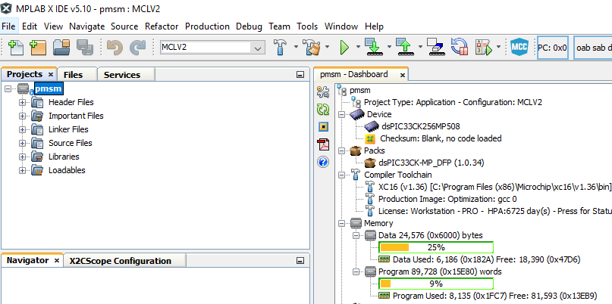

1. Set the project *pmsm.X* as main project by right clicking on the project name and selecting “Set as Main Project” as shown. The project “pmsm” will then appear in **bold**.

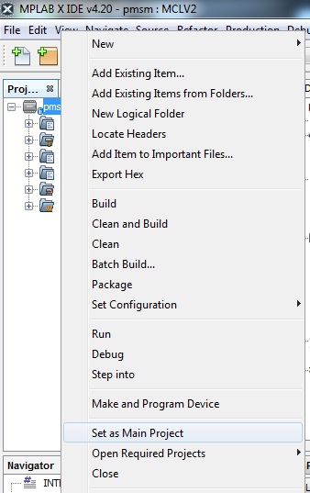

1. Select project configuration as “MCLV2” from the Project Configuration drop down box on the toolbar as shown:

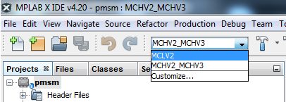

As shown in the figure above, there may be multiple project configurations available for *pmsm.X*.

1. Open userparams.h (under pmsm.X -> headerfiles) in the project pmsm.X and ensure that TUNING, OPEN_LOOP_FUNCTIONING, and TORQUE_MODE is not defined.
2. Open pim_select.h (under pmsm.X -> headerfiles->hal) in the project pmsm.X and ensure INTERNAL_OPAMP_PIM is defined as this demonstration is for Internal Op-Amp configuration.

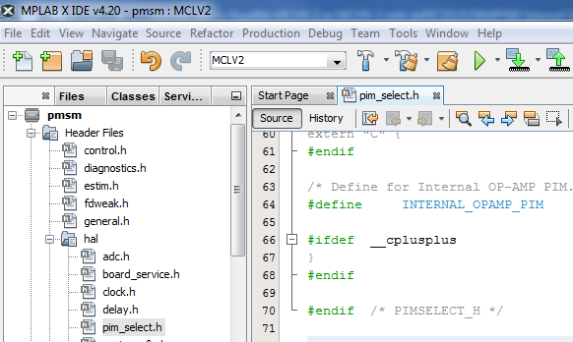

1. Open userparams.h (under pmsm.X -> headerfiles) in the project pmsm.X and ensure SINGLE_SHUNT is defined as this demonstration is for single shunt configuration. Undef SINGLE_SHUNT to work with dual shunt configuration.

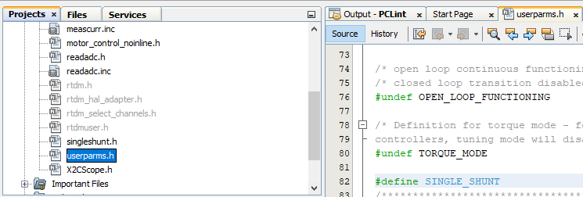

1. Right click on the project *pmsm.X* and select “Properties” to open its Project Properties Dialog. Click the “Conf: [MCLV2]” category to reveal the general project configuration information.

In the *‘****Conf-MCLV2’*** category window:

* Select the specific Compiler Toolchain from the available list of compilers. Please ensure MPLAB® XC16 Compiler supports the device dsPIC33CK256MP508.In this case “XC16(v1.36B)” is selected. The compiler used for testing the firmware is listed in the section 2.2 Software Tools Used for Testing the firmware.
* Select the Hardware Tool to be used for programming and debugging. In this case, “Real ICE” is the selected programmer.
* After selecting Hardware Tool and Compiler Toolchain, click button **Apply**

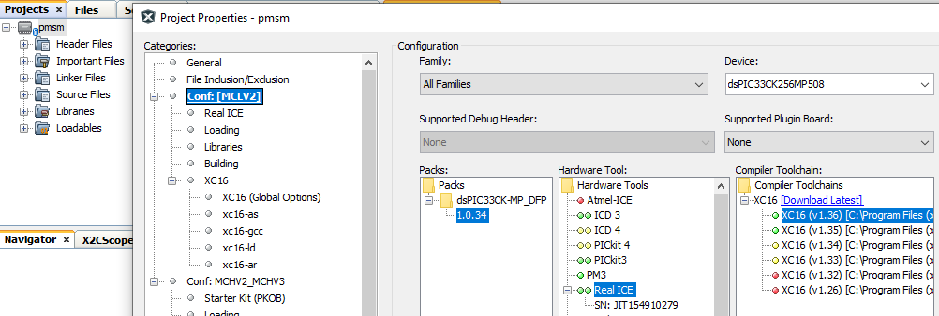

1. To build the project (in this case *pmsm.X*) and program the device dsPIC33CK256MP508, click “**Make and Program Device Main project**” on the toolbar.

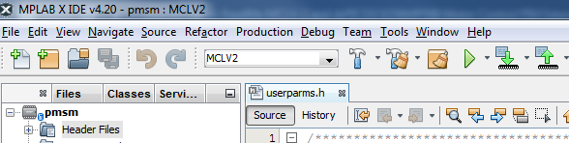

1. If the device is successfully programmed, **LED D2** will be turned ON, indicating that the dsPIC® DSC is enabled.
2. Run or Stop the motor by pressing the push button **S2**. The function of the pushbutton **S2** (Run/Stop of the motor) is indicated by turning ON or OFF the **LED D17**.

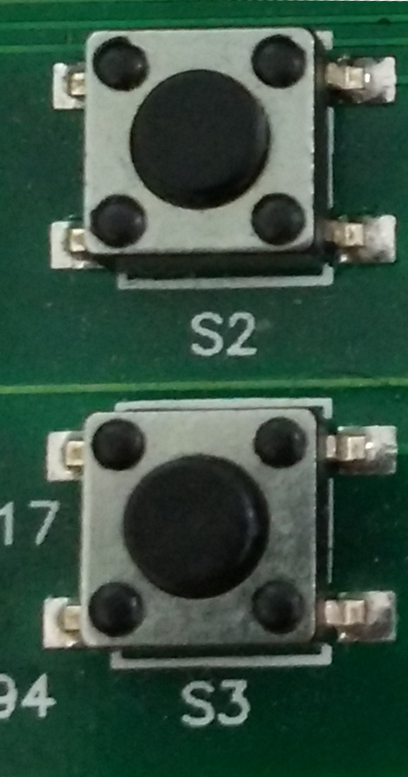

1. If desired, the motor speed can be varied using the potentiometer (labeled “POT1”).

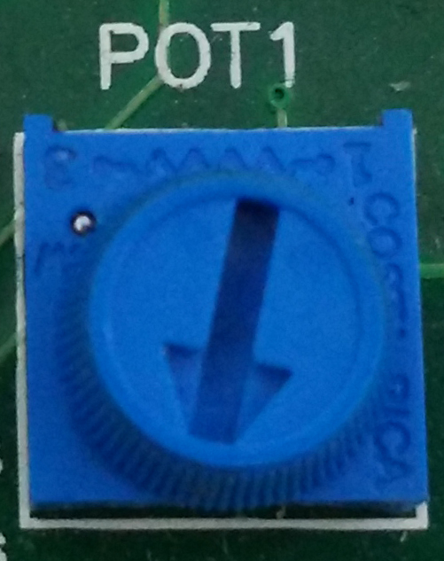

1. To enter the extended speed range (NOMINAL_SPEED_RPM to MAXIMUM_SPEED_RPM) press the push button **S3**. Press the push button **S3** again to revert the speed of the motor to its normal speed (END_SPEED_RPM to NOMINAL_SPEED_RPM) range.
2. Press the push button **S2** to stop the motor.

**Note:**

The macro definitions END_SPEED_RPM, NOMINAL_SPEED_RPM, and MAXIMUM_SPEED_RPM are specified in userparms.h file included in the project *pmsm.X*. The definitions NOMINAL_SPEED_RPM, and MAXIMUM_SPEED_RPM are defined as per the specification provided by the Motor manufacturer. *Exceeding manufacture specification may lead to damage of the motor or(and) the board.*

* 1. Data visualization through DMCI Plug-in of MPLABX

The project firmware comes with the software library for Real Time Data Monitoring (RTDM) needed to interface with DMCI Plug-in available in the MPLAB X IDE. RTDM, along with DMCI creates a communication link between a host PC and a target device for debugging applications in real-time. For additional information on DMCI, click on the [link](http://microchipdeveloper.com/mplabx:dmci) .For additional information on RTDM click on the [link](http://www.microchip.com/development-tools/resources/real-time-data-monitoring-tool---rtdm).

1. 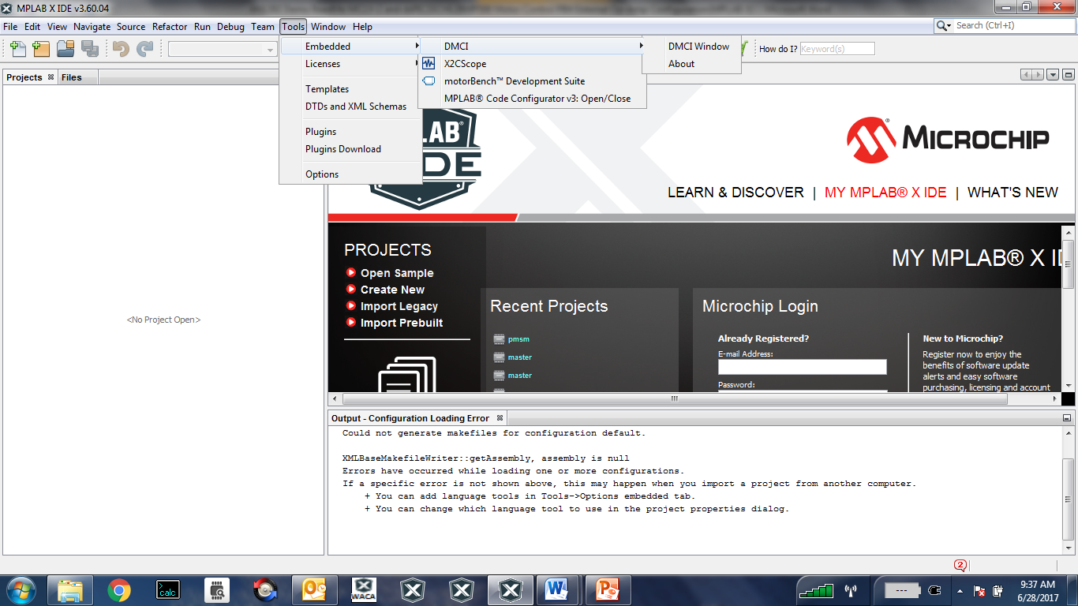Ensure DMCI Plug-in is installed. Look for DMCI under Tools>Embedded. If you do not see it, follow instructions provided in the section Setup: Data Monitor and Control Interface (DMCI) to install the plug-in.
2. To utilize RTDM communication for this demonstration, a mini-USB connection is required between Host PC and dsPICDEM™ MCLV-2 Development Board. Connect a mini-USB cable from your computer to the J8 connector of the dsPICDEM™ MCLV-2 Development Board.
3. Ensure application is configured and running as described under Section Basic Demonstration by following steps 1 through 12.
4. Select files **X2Cscope.h** and **diagnostics_x2cscope.c**, then right click and set Exclude file(s) from current configuration.

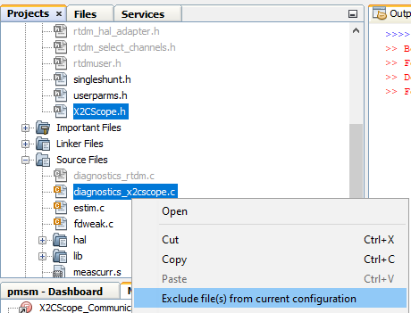

1. Select files **rtdm.h** , **rtdm_hal_adapter.h** , **rtdm_select_channels.**h , **rtdmuser.h**,and **diagnostics_rtdm.c** , then rightclick and set Include file(s) from current configuration to add these files as part of current Project Configuration. This will allow RTDM interface related files to be added to the project, required to enable RTDM interface.

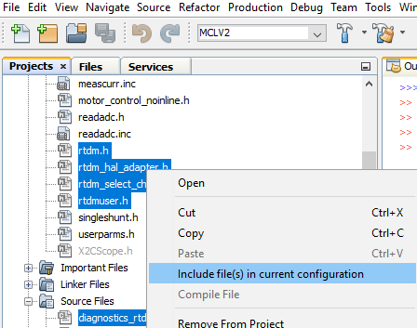

1. 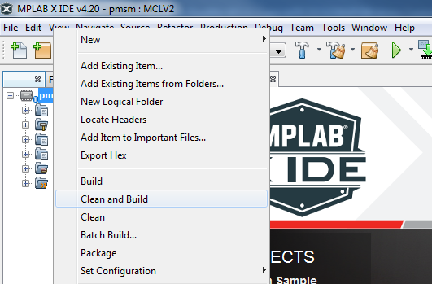Build the project *pmsm.X*. To do that right click on the project *pmsm.X* and select “Clean and Build”
2. 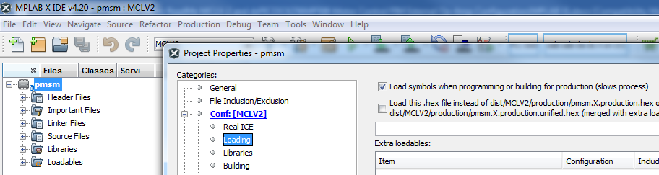Please ensure that the checkbox “Load symbols when programming or building for production (slows process)” is checked, which is under the “Loading” category of the Project Property dialog.
3. To build the project (in this case *pmsm.X*) and program the device dsPIC33CK256MP508, click “**Make and Program Device Main project**” on the toolbar.



1. Open the DMCI window by selecting Tools>Embedded>DMCI>DMCI Window.

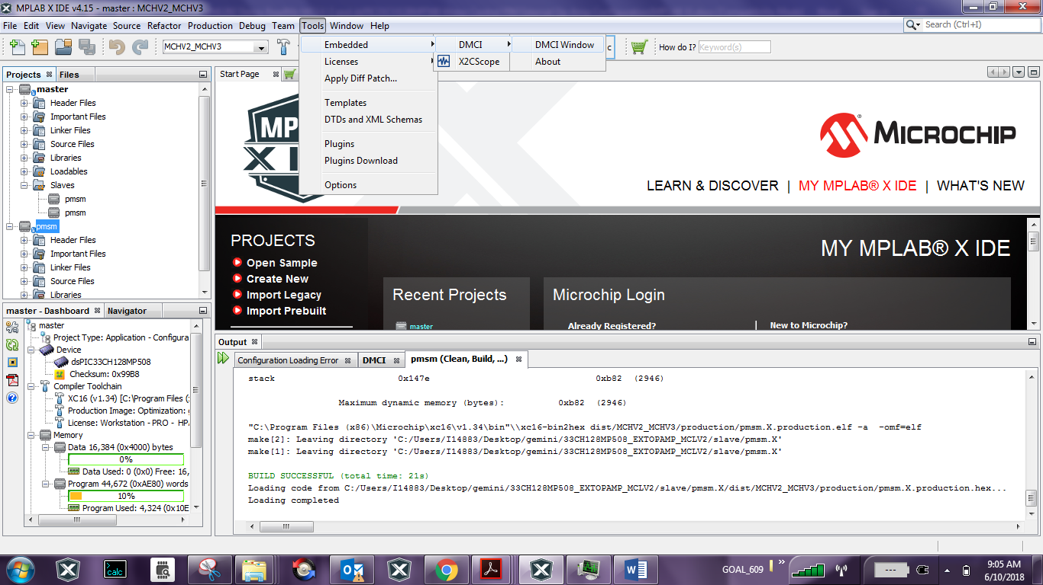

1. From the Select Project drop down menu availble in the DMCI window , select project *‘pmsm’*

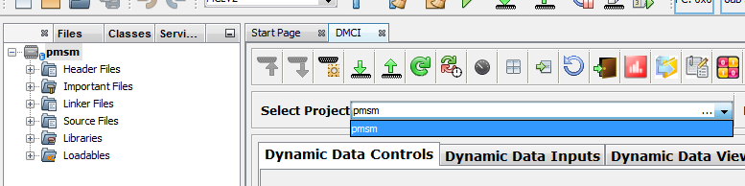

1. 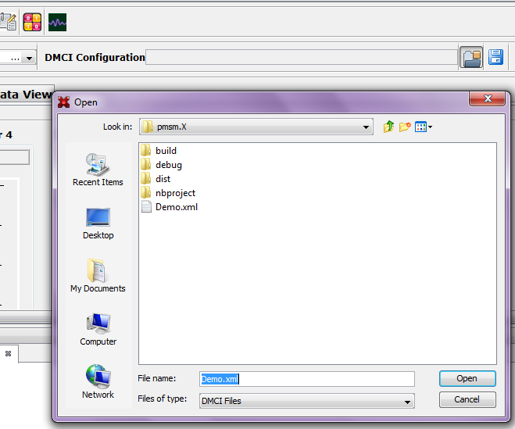Click the **Load Profile** icon, and load Demo.xml from the directory where project *pmsm.X* is located. The Demo.xml file contains a previously configured profile.
2. 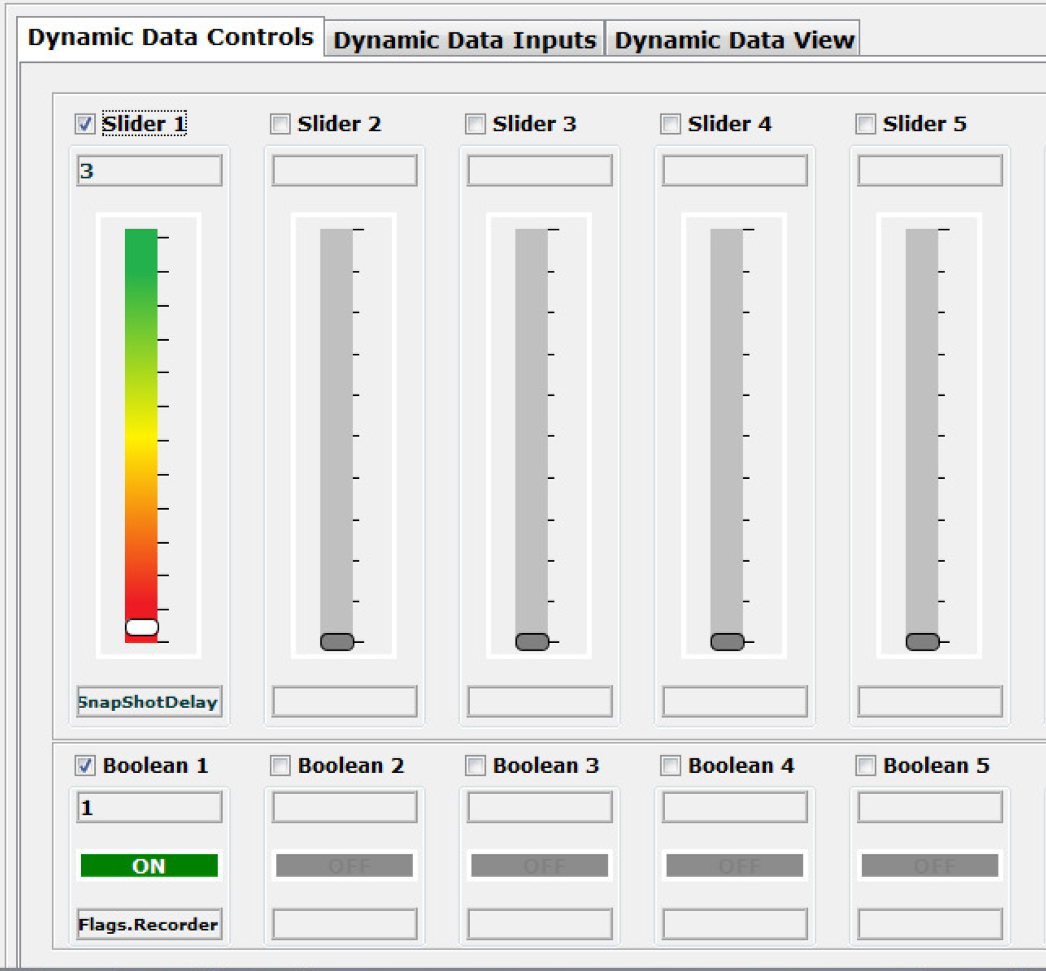The DMCI window appears as follows:

Please refer to the *“Real-Time Data Monitor User’s Guide”* (DS70567) for additional settings needed for a RDTM connection.

1. 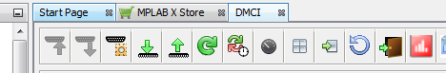Click **Serial Settings** to connect RTDM with your computer..
2. Remote Communication needs to be established, as indicated in the following figure (the communication baud rate should be set to 57600, while the COM port used depends on the your connection. Click on **Test** to detect the communication link.
3. Once communication is detected, make sure the “Enable Communication” box is checked and click **OK**.
4. 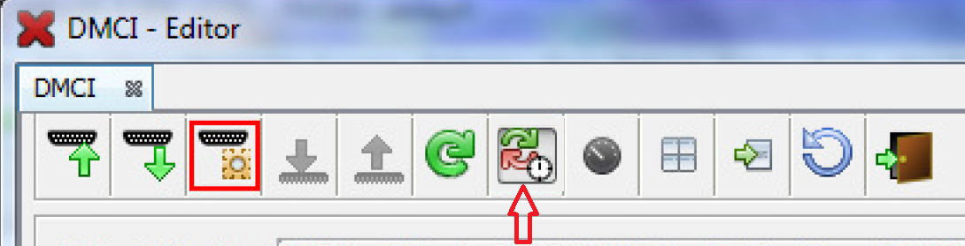To plot variables in real time, enable “Automated Event Control” by clicking **Automatic Event Execution** icon found on the toolbar.
5. 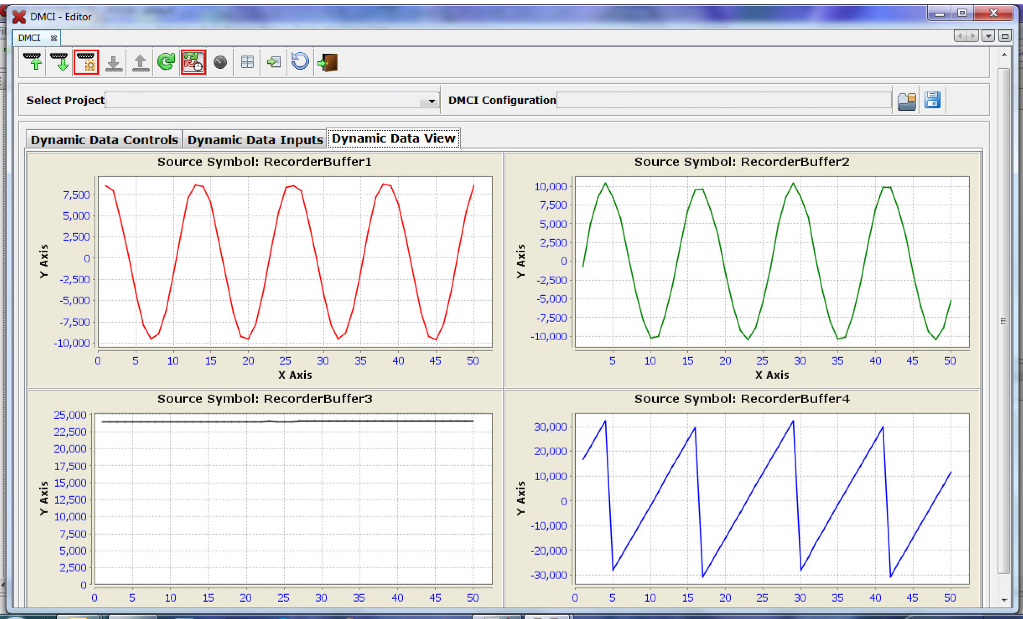The DMCI window shows variables plotted in real time, which is updated automatically.
6. 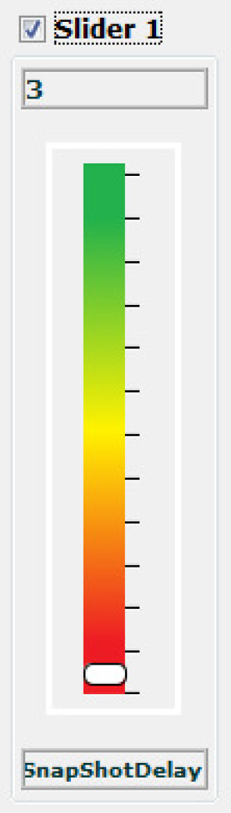To change the time window to see data over larger time span, change the value of the ‘SnapShotDelay’, which controls how the buffers are being filled.
7. The variables displayed through DMCI/RTDM plug-in is set in rtdm_select_channels.c,user may change the varibles to be displayed by modifying the address assigned to the arrays addresses[0],addresses[1],addresses[2] and addresses[3].The array addresses[0] corresponds to Graph1, addresses[1] corresponds to Graph2 ,and so on.

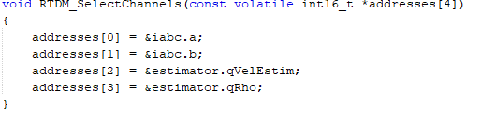

1. Data visualization through X2CScope Plug-in of MPLABX

The application firmware comes with initialization required to interface Controller with Host PC to enable Data visualization through X2C Scope plug-in. X2C-Scope is a third-party plugin for MPLAB X which facilitates real-time diagnostics.

1. Ensure X2C Scope Plug-in is installed. For additional information on how to set up a plug-in refer to

<https://microchipdeveloper.com/mplabx:tools-plugins-available>



1. To utilize X2-C communication for this demonstration, a mini-USB connection is required between Host PC and dsPICDEM™ MCLV-2 Development Board. Connect a mini-USB cable from your computer to the J8 connector of the dsPICDEM™ MCLV-2 Development Board.
2. Ensure application is configured and running as described under Section Basic Demonstration by following steps 1 through 12.
3. Select files **rtdm.h** , **rtdm_hal_adapter.h** , **rtdm_select_channels.**h , **rtdmuser.h**,and **diagnostics_rtdm.c** , then rightclick and set Exclude file(s) from current configuration.

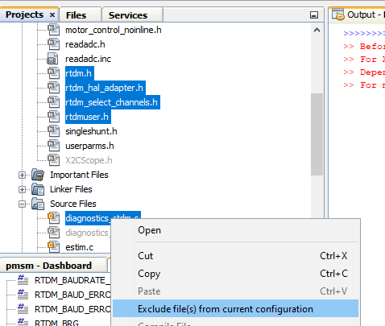

1. Select files **X2Cscope.h and diagnostics_x2cscope.c**, then right click and set **Include file(s) from current configuration** to add these files as part of current Project Configuration. This will allow X2C Scope interface related files to be added to the project and is required to enable X2C Scope.

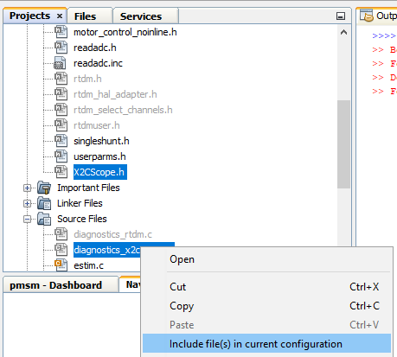

1. Build the project *pmsm.X*. To do that right click on the project *pmsm.X* and select “Clean and Build”.
2. Please ensure that the checkbox “Load symbols when programming or building for production (slows process)” is checked, which is under the “Loading” category of the Project Property dialog
3. To build the project (in this case *pmsm.X*) and program the device dsPIC33CK256MP508, click “**Make and Program Device Main project**” on the toolbar.



1. Open the X2C window by selecting Tools>Embedded>X2CScope.



1. Open the X2CScope Configuration window and in “Select project” menu, select pmsm.X project as shown.

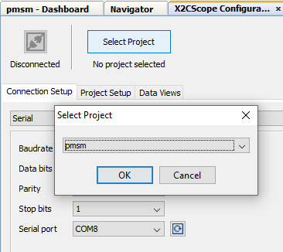

1. Remote Communication needs to be established, as indicated in the following figure (the communication baud rate should set to 115200, while COM port used depends on your settings. Click on Refresh button to detect COM Port automatically.

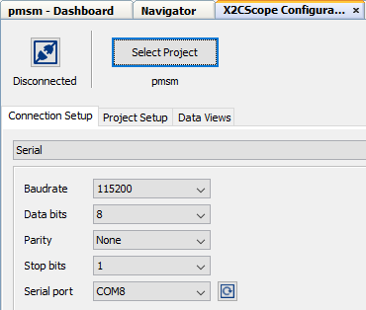

1. Once COM port detected, click on “**Disconnected**”, and it will be turn into “**Connected**”, if the link is established as programmed.

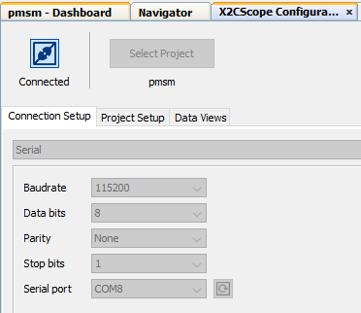

1. Set the “Project Setup” as shown below and click “Set Values”. Set Scope sampling time as interval at which X2CScopeUpdate() is called. In this application it is every 20kHz (50Us).

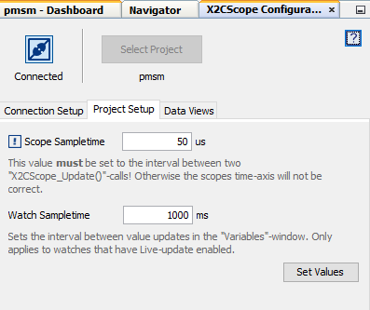

1. When the setup is established, click on open scope View (under sub window “Data Views”), this open Scope Window.

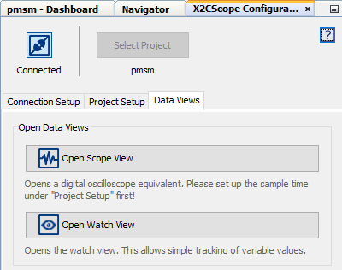

1. In the window select the variables user may want to watch. Click on the source, a window Select Variables opens upon the screen. From the select variables list, choose the variable that you want to view. Then ensure Enable, Visible check boxes are checked as shown.

To view data plots continuously uncheck Single-shot. When Single-shot is checked it captures the data once and stops, if trigger occurs. Change the Sample time factor value to change the time window.

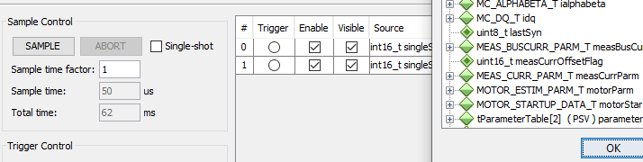

1. Click on SAMPLE, then X2C scope window shows variables in real time, which is updated automatically.

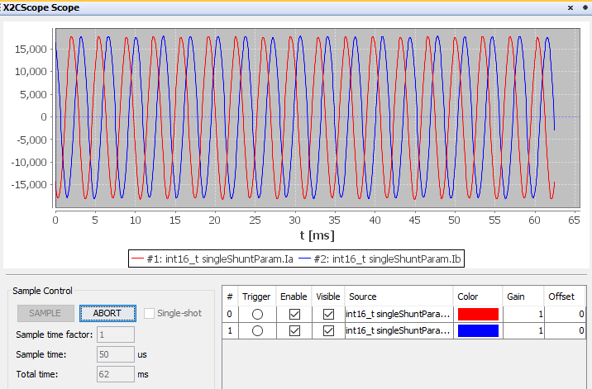

1. Click on ABORT to stop.



1. dsPIC® DSC RESOURCE USAGE SUMMARY
   1. Device Pin Mapping and Its Functionality in the Firmware:

The following table summarizes device pins configured and used in the AN1299 motor control application firmware demonstrated using the Development Board and the dsPIC33CK256MP508 Internal Op-Amp Motor Control PIM(MA330041-2). Refer “*dsPIC33CK256MP508 Internal Op-Amp Motor Control Plug-in-Module (PIM) Information Sheet(DS50002756)”* for more information.

|  |  |  |  |  |  |
| --- | --- | --- | --- | --- | --- |
| Functional Description | PIM PIN Number | Device PIN Number | Device Pin Name | Signal Type | Remarks |
| **Motor Control PWMs and Fault Input** | | | | | |
| PWM1H | PIM:94 | 1 | RP46/**PWM1H**/PMD5/**RB14** | PWM  Output | Controls  Hex Bridge MOSFET Q5 |
| PWM1L | PIM:93 | 3 | RP47/**PWM1L**/PMD6/**RB15** | PWM  Output | Controls  Hex Bridge MOSFET Q6 |
| PWM2H | PIM:99 | 78 | TDI/RP44/**PWM2H**/PMD3/**RB12** | PWM  Output | Controls  Hex Bridge MOSFET Q3 |
| PWM2L | PIM:98 | 80 | RP45/**PWM2L**/PMD4/**RB13** | PWM  Output | Controls  Hex Bridge MOSFET Q4 |
| PWM3H | PIM:03 | 75 | TMS/RP42/**PWM3H**/PMD1/**RB10** | PWM  Output | Controls  Hex Bridge MOSFET Q1 |
| PWM3L | PIM:100 | 76 | TCK/RP43/**PWM3L**/PMD2/**RB11** | PWM  Output | Controls  Hex Bridge MOSFET Q2 |
| FAULT_MC | PIM:18 | 49 | RP72/SDO2/**PCI19**/**RD8** | PWM  Input | Connected to  Over Current Fault Output |
| **Analog Inputs – Phase Currents, Speed Reference** | | | | | |
| POT | PIM:32 | 36 | **AN19**/CMP2C/RP75/PMA0/PMALL/PSA0/**RD11** | Analog Input | Speed Reference  Connected to Potentiometer POT1 |
| IBUS+ | PIM:66 | 20 | OA1IN+/AN9/PMA6/RA2 | Analog Input | Op-Amp 1 Non-Inverting Input  (Internal to dsPIC33CK256MP508) |
| IBUS- | PIM:67 | 18 | OA1IN-/ANA1/RA1 | Analog Input | Op-Amp 1 Inverting Input (Internal to dsPIC33CK256MP508) |
| IBUS (Amplified Bus Current) | Not Applicable | 16 | OA1OUT/AN0/CMP1A/IBIAS0/RA0 | Analog Input | Op-Amp 1 Output  (Internally connected to dsPIC33CK256MP508’s ADC) |
| IA+ | PIM:74 | 45 | PGC2/**OA2IN+**/RP36/RB4 | Analog Input | Op-Amp 2 Non-Inverting Input (Internal to dsPIC33CK256MP508) |
| IBUS+ | PIM:66 | 43 | PGD2/**OA2IN-**/AN8/RP35/RB3 | Analog Input | Op-Amp 2 Inverting Input (Internal to dsPIC33CK256MP508) |
| IMOTOR1 (Amplified IA) | Not Applicable | 41 | **OA2OUT**/**AN1**/AN7/ANA0/CMP1D/CMP2D/CMP3D/RP34/  SCL3/INT0/RB2 | Analog Output | Op-Amp 2 Output  (Internally connected to dsPIC33CK256MP508’s ADC) |
| IB+ | PIM:73 | 29 | **OA3IN**+/AN14/CMP2B/ISRC1/RP50/PMD13/PMA13/RC2 | Analog Input | Op-Amp 3 Non-Inverting Input  (Internal to dsPIC33CK256MP508) |
| IBUS+ | PIM:66 | 28 | **OA3IN**-/AN13/CMP1B/ISRC0/RP49/PMA7/RC1 | Analog Input | Op-Amp 3 Inverting Input (Internal to dsPIC33CK256MP508) |
| IMOTOR2 (Amplified IB) | Not Applicable | 23 | **OA3OUT**/**AN4**/CMP3B/IBIAS3/RA4 | Analog Output | Op-Amp 3 Output  (Internally connected to dsPIC33CK256MP508’s ADC) |
| **Miscellaneous Signals** | | | | | |
| BTN_1 | PIM:83 | 54 | RP69/PMA15/PMCS2/**RD5** | Digital  Input | Connected to Push Button S2 |
| BTN_2 | PIM:84 | 39 | **RE7** | Digital Input | Connected to Push Button S3 |
| Debug LED1 | PIM:60 | 42 | **RE8** | Digital Output | Connected to LED D17 |
| Debug LED2 | PIM:01 | 44 | **RE9** | Digital  Output | Connected to LED D2 |
| RX (UART) | PIM:49 | 52 | **RP71**/PMD15/**RD7** | UART1  Input | Connected to UART-USB converter to establish serial communication interface between Host PC and the dsPIC® DSC as needed by DMCI-RTDM. |
| TX (UART) | PIM:50 | 53 | **RP70**/PMD14/**RD6** | UART1  Output | Connected to UART-USB converter to establish serial communication interface between Host PC and the dsPIC® DSC as needed by DMCI-RTDM. |

1. REFERENCES:

For additional information, refer following documents or links.

1. AN1299 Application Note “Single-Shunt Three-Phase Current Reconstruction Algorithm for Sensorless FOC of a PMSM”
2. AN1292 Application Note “Sensorless Field Oriented Control (FOC) for a Permanent Magnet Synchronous Motor (PMSM) Using a PLL Estimator and Field Weakening (FW)”
3. dsPICDEM™ MCLV-2 Development Board User’s Guide(DS52080)
4. dsPIC33CK256MP508 Internal Op-Amp Motor Control Plug-in-Module (PIM) Information Sheet(DS50002756)
5. dsPIC33CK256MP508 Family datasheet(DS70005349).
6. Family Reference manuals (FRM) of dsPIC33CK256MP508 family
7. MPLAB® X IDE User’s Guide (DS50002027) or MPLAB® X IDE help
8. Real-Time Data Monitor User’s Guide (DS70567) or [Real Time Data Monitoring Tool - RTDM](http://www.microchip.com/development-tools/reference-designs/real-time-data-monitoring-tool---rtdm)
9. [Data Monitor and Control Interface - Developer Help](http://microchipdeveloper.com/mplabx:dmci)
10. [MPLAB® X IDE installation](http://microchipdeveloper.com/mplabx:installation)
11. [MPLAB® XC16 Compiler installation](http://microchipdeveloper.com/xc16:installation)